Berekeningen met behulp van integralen
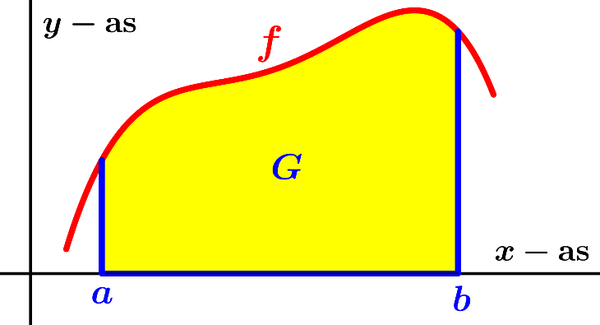 | 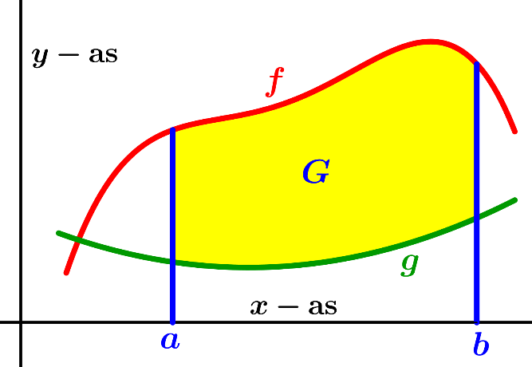
$opp.\left(G\right)=\int_{a}^{b}{f\left(x\right) dx}$ | $opp.\left(G\right)=\int_{a}^{b}{\left\{f\left(x\right)-g\left(x\right)\right\} dx}$  Deze formule blijft juist als (een gedeelte van) $G$ onder de $x-$as ligt.

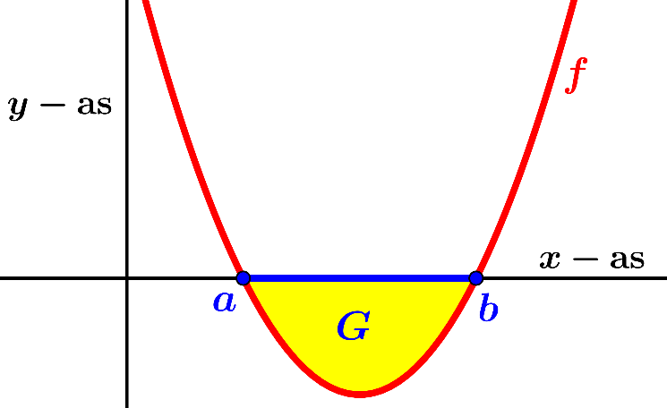 | 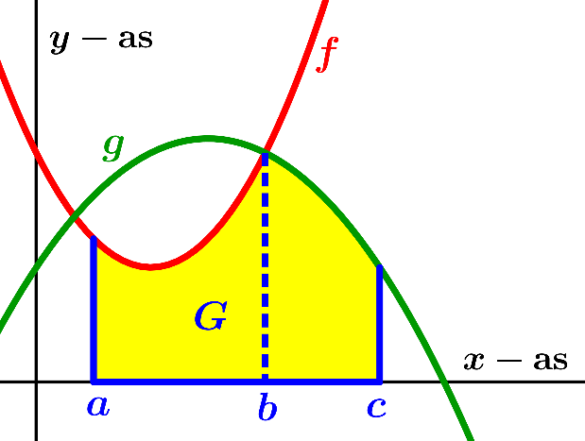
$opp.\left(G\right)=-\int_{a}^{b}{f\left(x\right) dx}$ | $opp.\left(G\right)=\int_{a}^{b}{f\left(x\right)}dx+\int_{b}^{c}{g\left(x\right)}dx$

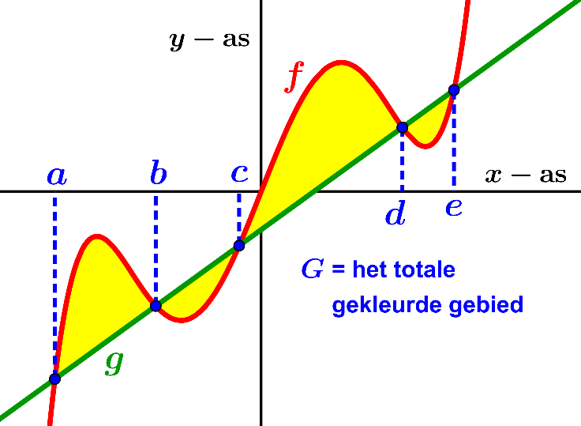 |  | $opp.(G)=\int_{a}^{e}{\left|f\left(x\right)-g\left(x\right)\right|}dx$  Dit kan met de integraaltoets op de RM berekend worden of aldus  (zo nodig algebraïsch)  $opp.\left(G\right)=\int_{a}^{b}{\left\{f\left(x\right)-g\left(x\right)\right\}}dx+\int_{b}^{c}{\left\{g\left(x\right)-f\left(x\right)\right\}}dx+\int_{c}^{d}{\left\{f\left(x\right)-g\left(x\right)\right\}}dx$  $+\int_{d}^{e}{\left\{g\left(x\right)-f\left(x\right)\right\}}dx$
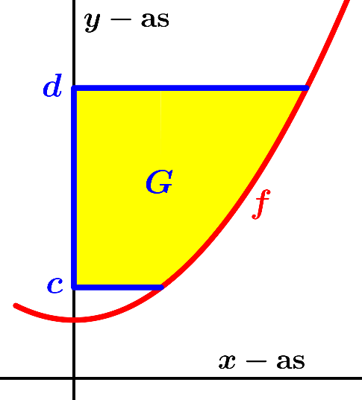 | 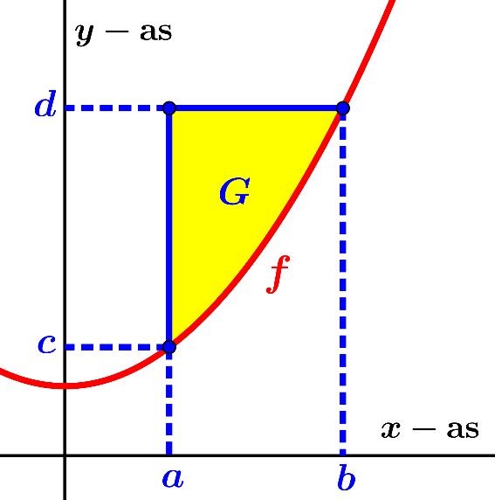
$opp.\left(G\right)=\int_{c}^{d}{f^{inv}\left(y\right) dy}$ | $opp.\left(G\right)=\int_{a}^{b}{\left\{d-f\left(x\right)\right\}dx}=\int_{c}^{d}{\left\{f^{inv}(y)-a\right\} dy}$

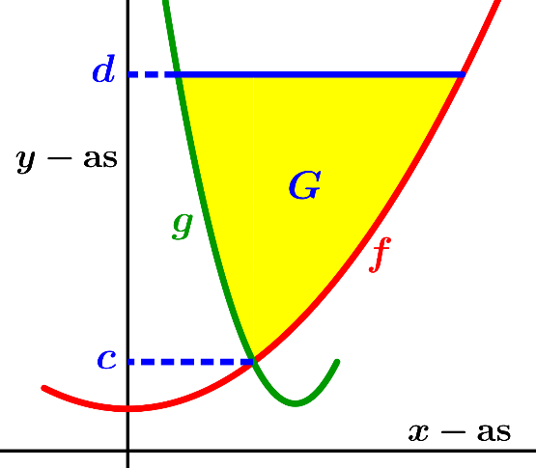 | 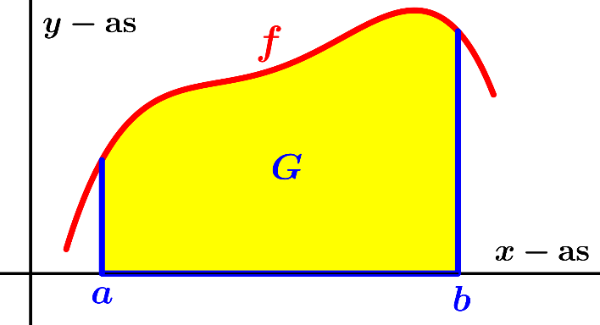
$opp.\left(G\right)=\int_{c}^{d}{\left\{f^{inv}\left(y\right)-g^{inv}(y)\right\} dy}$ | $I_{ x-as}\left(G\right)=π\int_{a}^{b}{{\left(f(x)\right)}^{2}dx=π\int_{a}^{b}{y^{2}dx , }}$  $waarbij y=f(x)$
 | 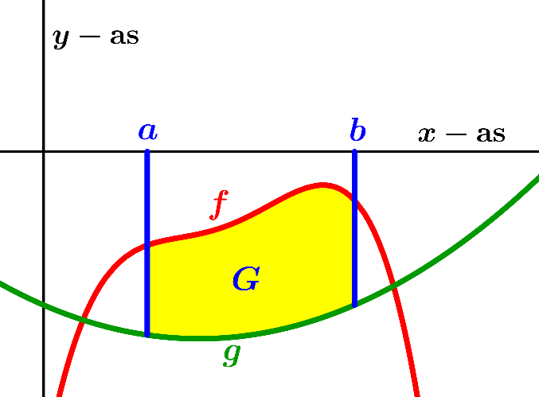
$I_{ x-as}\left(G\right)$ $=π\int_{a}^{b}{\left\{{\left(f(x)\right)}^{2}-{\left(g(x)\right)}^{2}\right\} dx}$ | $I_{ x-as}\left(G\right)=$ $π\int_{a}^{b}{\left\{{\left(g(x)\right)}^{2}-{\left(f(x)\right)}^{2}\right\} dx}$
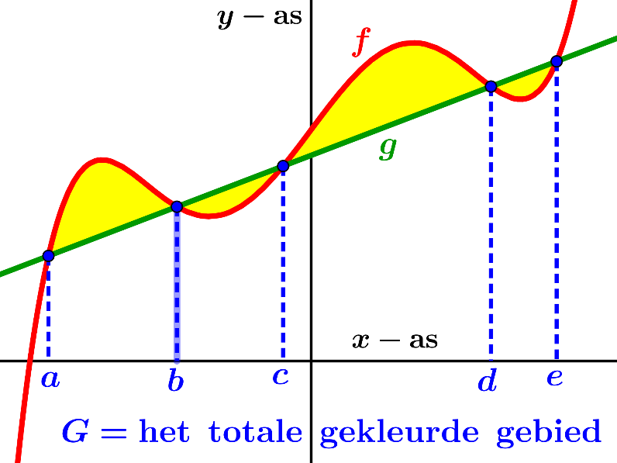
$I_{ x-as}\left(G\right)=π\int_{a}^{e}{\left|{\left(f(x)\right)}^{2}-{\left(g(x)\right)}^{2}\right| dx}$
Deze formule is handig indien men met de integraaltoets op de rekenmachine een benadering voor de inhoud wil bepalen.
Bij een algebraïsche berekening (m.b.v. de primitieve) dient men te gebruiken
$I_{ x-as}\left(G\right)=π\int_{a}^{b}{\left\{{\left(f(x)\right)}^{2}-{\left(g(x)\right)}^{2}\right\}}dx+π\int_{b}^{c}{\left\{{\left(g(x)\right)}^{2}-{\left(f(x)\right)}^{2}\right\}}dx$
$+ π\int_{c}^{d}{\left\{{\left(f(x)\right)}^{2}-{\left(g(x)\right)}^{2}\right\}}dx+π\int_{d}^{e}{\left\{{\left(g(x)\right)}^{2}-{\left(f(x)\right)}^{2}\right\}}dx$
 | 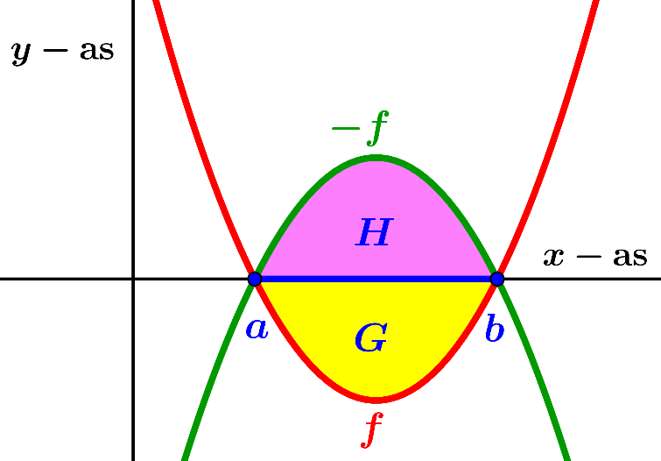
$I_{ x-as}\left(G\right)=$ $π\int_{a}^{b}{{\left(f(x)\right)}^{2}dx}+π\int_{b}^{c}{{\left(g(x)\right)}^{2}dx}$ | $I_{ x-as}(G)=π\int_{a}^{b}{{\left(f(x)\right)}^{2}dx}$  want${ I}_{ x-as}\left(G\right)=I_{ x-as}\left(H\right)$  $=π\int_{a}^{b}{{\left(-f(x)\right)}^{2}dx=π\int_{a}^{b}{{\left(f(x)\right)}^{2}dx}}$

$I_{y-as }\left(G\right)=π\int_{c}^{d}{{\left\{f^{inv}(y)\right\}}^{2}dy}$  $\left(=\int_{c}^{d}{x^{2}dy , waarbij x=f^{inv}(y)}\right)$ | $I_{y-as }\left(G\right)=$ $π\int_{c}^{d}{\left({\left\{f^{inv}(y)\right\}}^{2}-{\left\{g^{inv}(y)\right\}}^{2}\right) dy}$
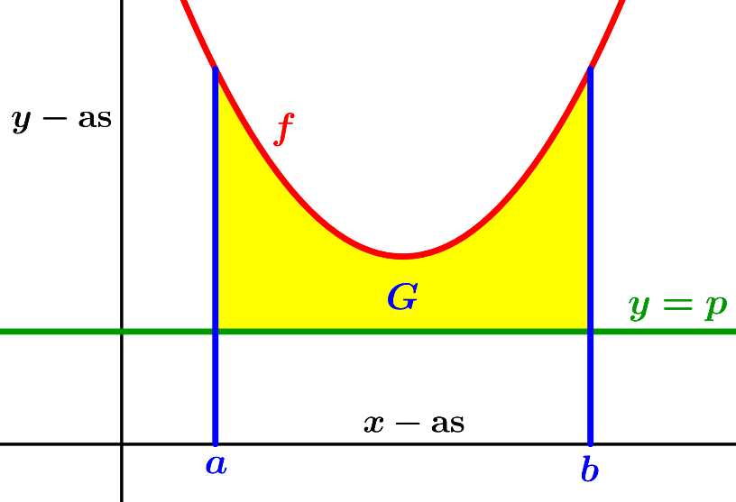 |  | 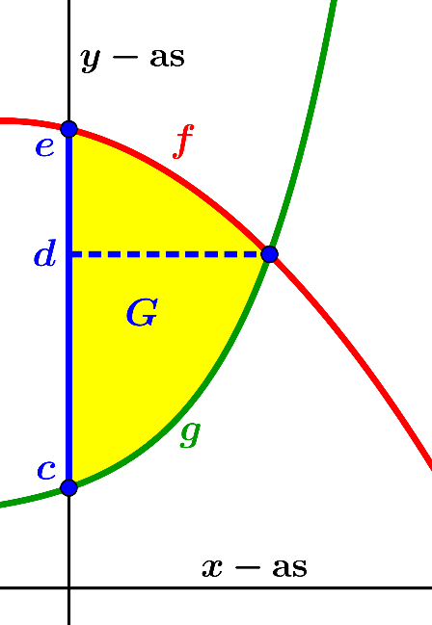
$I_{y = p}\left(G\right)=π\int_{a}^{b}{{\left(f\left(x\right)-p\right)}^{2}dx}$ ${ I}_{y-as }\left(G\right)=π\int_{c}^{d}{{\left\{g^{inv}(y)\right\}}^{2}dy+π\int_{d}^{e}{{\left\{f^{inv}(y)\right\}}^{2}dy}}$
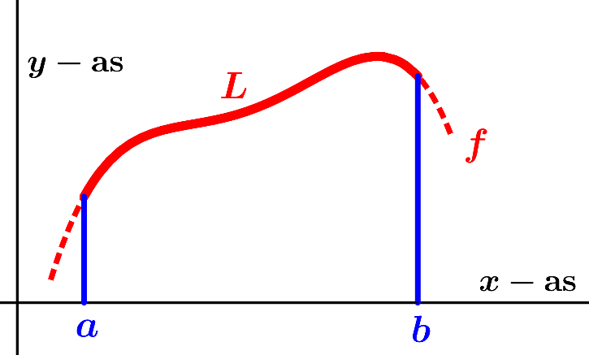
$L=$ lengte grafiek voor $a≤x≤b$. $O=$ oppervlakte omwentelingslichaam
$L=\int_{a}^{b}{\sqrt{1+{(f^{'}\left(x\right))}^{2}}} dx$ $O_{ x-as}\left(G\right)=2π\int_{a}^{b}{f\left(x\right)\sqrt{1+{(f^{'}\left(x\right))}^{2}} dx}$
$Z=$ zwaartepunt gebied
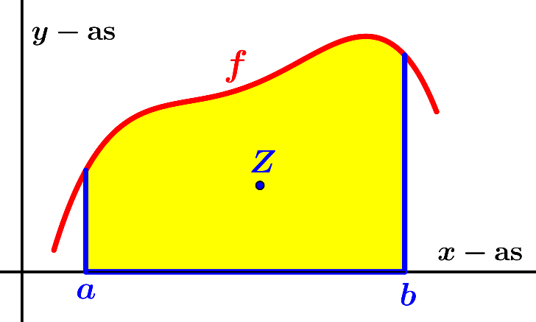 | 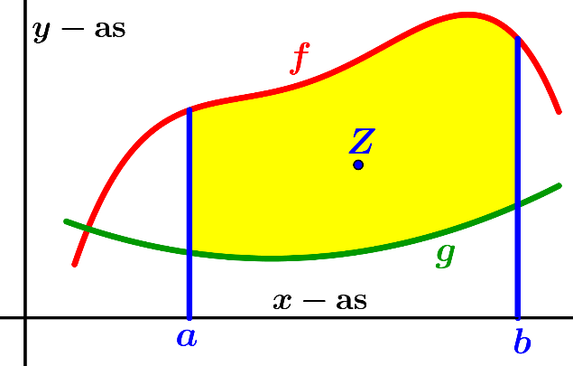
$x_{Z}={\int_{a}^{b}{x∙f\left(x\right)dx}}/{\int_{a}^{b}{f\left(x\right) dx}}$ $x_{Z}={\int_{a}^{b}{x∙\left\{f\left(x\right)-g(x)\right\}dx}}/{\int_{a}^{b}{\left\{f\left(x\right)-g(x)\right\} dx}}$
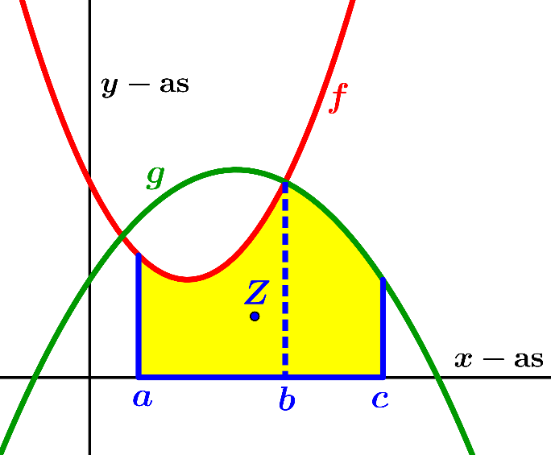 | 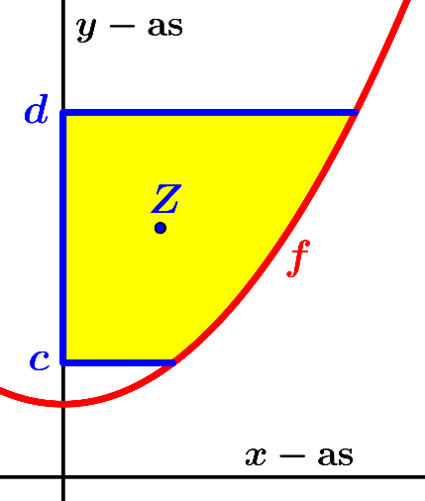
$x_{Z}=$ $\frac{\int_{a}^{b}{x ∙ f\left(x\right) dx} + \int_{b}^{c}{x ∙ g\left(x\right) dx} }{\int_{a}^{b}{f\left(x\right) dx} + \int_{b}^{c}{g\left(x\right) dx}}$ $y_{Z}={\int_{a}^{b}{y∙f^{inv}\left(y\right)dy}}/{\int_{a}^{b}{f^{inv}\left(y\right) dy}}$
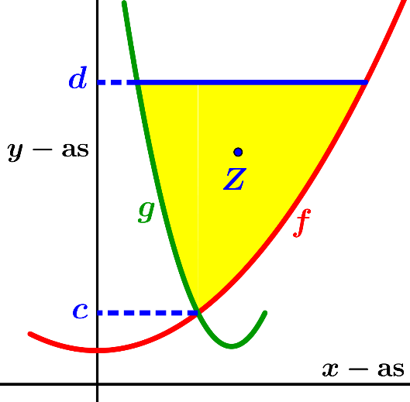
$y_{Z}=$ $\frac{\int_{c}^{d}{y ∙ \left\{f^{inv}\left(y\right)-g^{inv}\left(y\right)\right\} dy} }{\int_{c}^{d}{ \left\{f^{inv}\left(y\right)-g^{inv}\left(y\right)\right\} dy}}$

